**---------------------------------------**

**Linux Tasks**

**---------------------------------------**

1. **Mail command**

* **Sending History of commands**

1. **Store history in file**
2. **Download mail command library**
3. **Send HistoryFile using mail command**

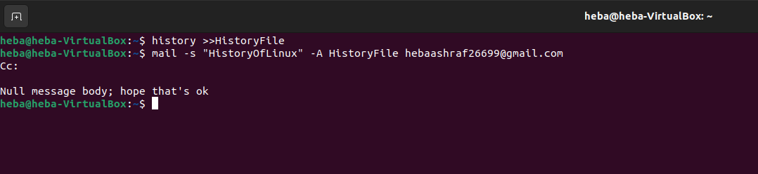

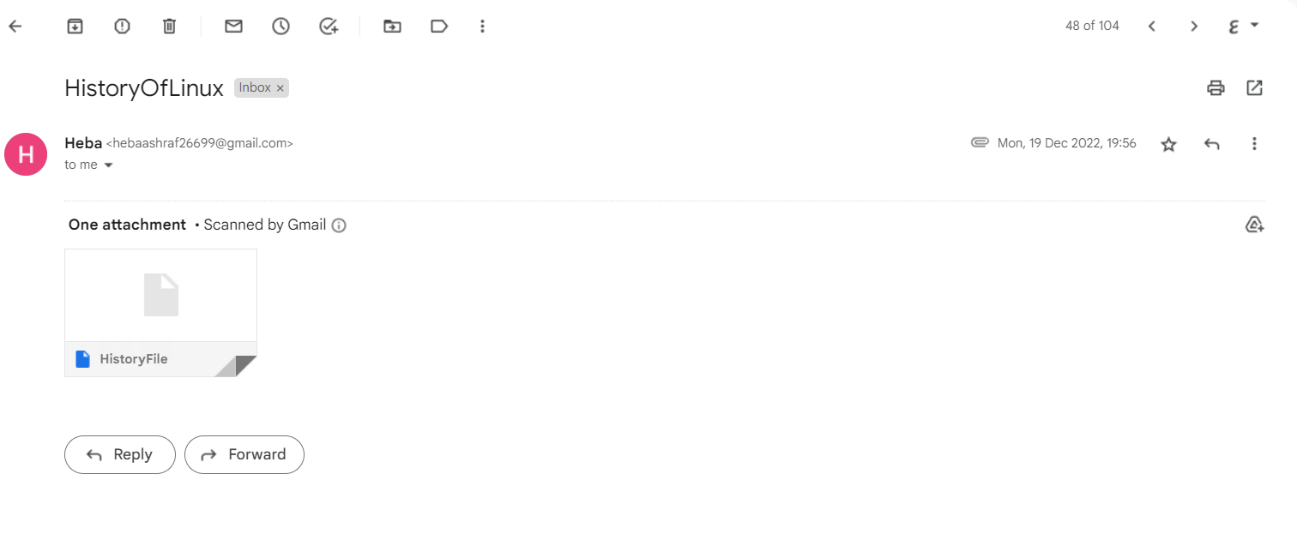

* **Sending Error of power system**

1. **Store errors in file**
2. **Send ErrorFile using mail command**

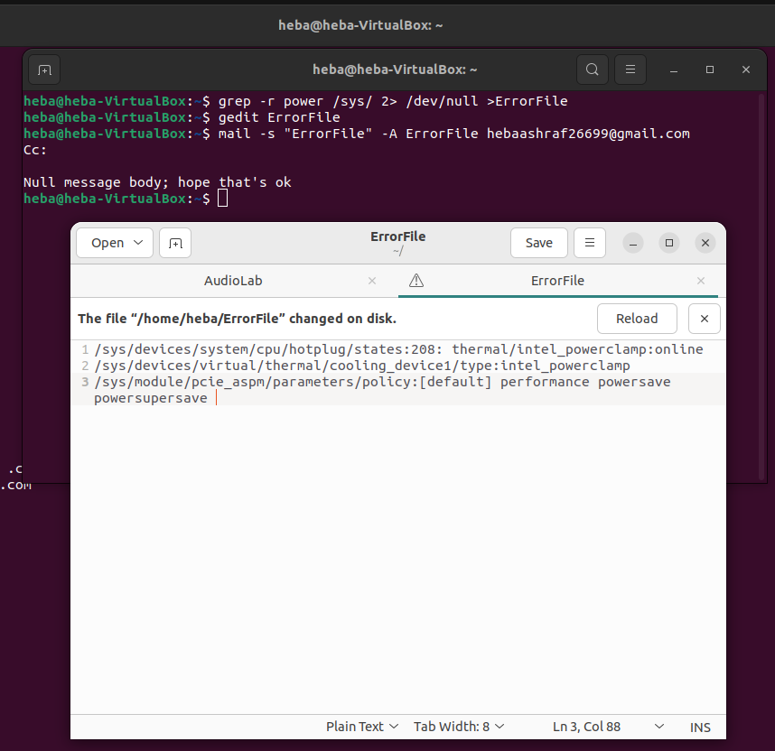

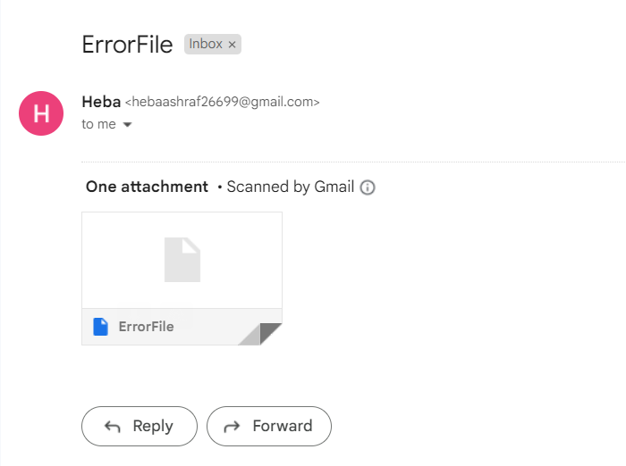

* **Sending content of passwd file in linux**

1. **Using soft copy which result password file with same content of passwd file**
2. **Sending PasswordFile using mail command**

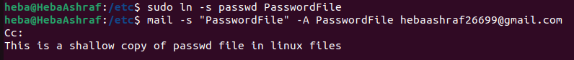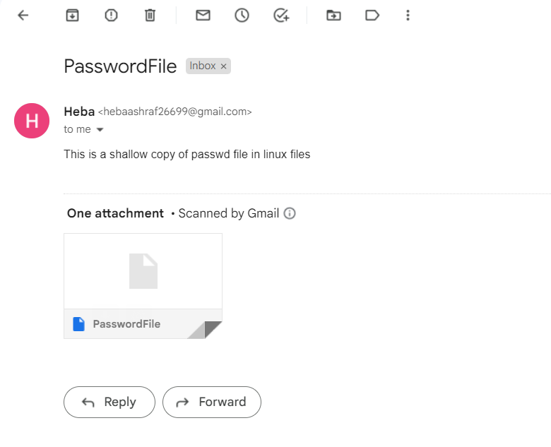

1. **Make Audio works every 5min**
2. **Download audio from YouTube**
3. **Download VLC using sudo snap install vlc**



1. **Make while loop**



